Georgetown University McDonough School of Business MSc. Management

Firm Analysis & Strategy 2

Final Project Write-up

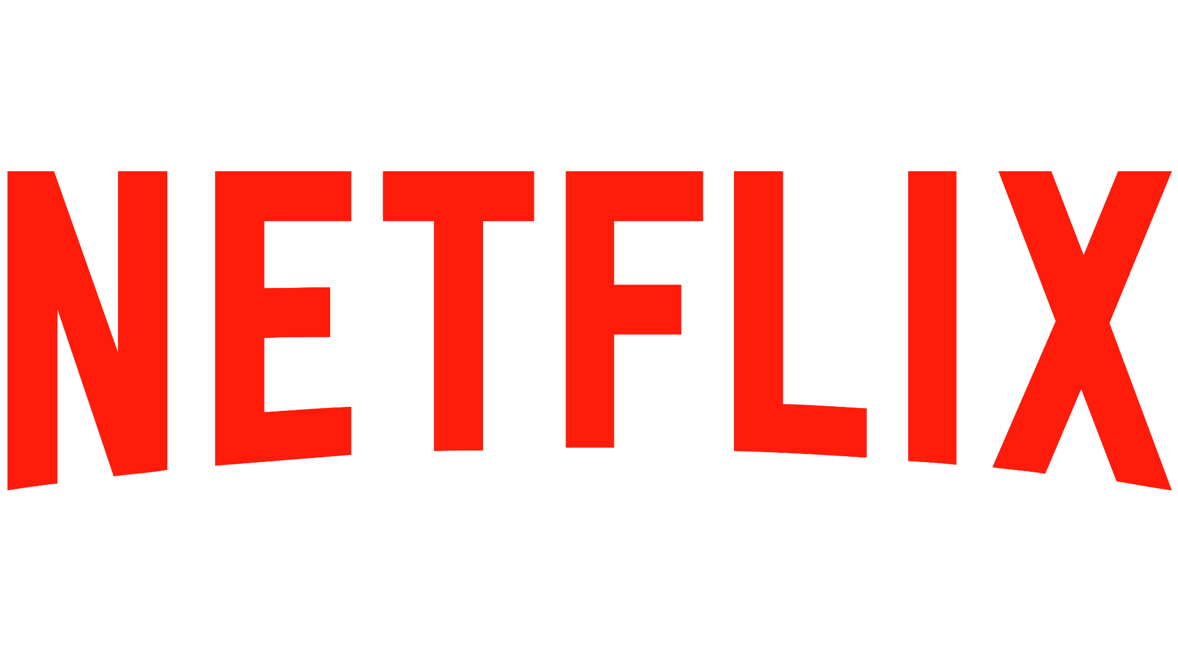

**May 2023**

## Company Background

Established in 1997, **Netflix** is a multinational entertainment company that initially focused on DVD mail-order rentals. However, in 2007, it revolutionized the media consumption landscape by introducing its streaming service. Today, Netflix stands as one of the leading streaming platforms worldwide, catering to millions of customers with an extensive collection of movies, TV episodes, and original content.

Driven by its **Mission**, Netflix strives to deliver exceptional entertainment to viewers through a user-friendly streaming platform tailored to their preferences. The company is renowned in the streaming industry for its convenience, affordability, and diverse content offerings. Guided by its **Values**, Netflix places a strong emphasis on innovation, inclusivity, and prioritizing the demands of its customers. With an overarching **Vision**, Netflix aims to establish global leadership in the streaming entertainment space by expanding its international presence, investing in original

content, and enhancing its platform and user experience.

For a better understanding of Netflix, we can examine its **Positioning Statement** which states that *"Netflix is the world's leading streaming entertainment service, offering a wide variety of TV shows, movies, documentaries, and more, with personalized recommendations and a seamless user experience."*

## Creating and Capturing Value

Netflix is one of the unique firms which in their own ways creates and captures value. Their subscription-based model and investment in original content **generate customer value**.

Customers have access to a diverse library of TV shows, movies, and documentaries, with personalized recommendations and viewing profiles enhancing the experience. Exclusive

original content sets Netflix apart from competitors, attracting and retaining subscribers. Netflix **captures value** through its revenue-generating subscription fees, ensuring a profitable business model.

## Media and Entertainment Industry

The Media and Entertainment Industry in the US holds a dominant position globally,

representing approximately $717 billion, or one-third of the market. Netflix is a key player in this industry, especially in the film and television segment, which accounts for 75% of the US M&E industry. Netflix's success can be attributed to its utilization of technology, innovation,

creativity, responsiveness to consumer demands, and favorable business conditions, particularly its pioneering role in video-on-demand streaming services.

The movies and entertainment sub-industry has witnessed consolidation through mergers and acquisitions, resulting in a reduction in the number of competitors. This trend reflects a movement toward fewer dominant companies as organizations combine their assets to enhance

competitiveness. The audiovisual supply chain **(Exhibit 1)** consists of various significant actors that not only influence the industry but also contribute to its overall success.

## External Analysis and Profitability of the M&E Industry

Strategic management involves conducting an external analysis using Porter's five forces

framework to evaluate the organization's external operating environment. This analysis examines industry profitability and identifies strategic opportunities and threats that can significantly impact the company's success.

## Threat of New Entrants - LOW

The threat of new entrants for Netflix is relatively lower in the streaming media industry. Netflix currently enjoys a dominant market position, the barriers to entry are high due to upfront capital and customer loyalty, which makes it harder for new players to compete with Netflix. **Exhibit 2** provides a comprehensive evaluation of entry barriers.

## Bargaining Power of Buyers - HIGH

In the movies and entertainment sub-industry, there are two significant buyer groups: subscribers and advertisers. Subscribers refer to customers who make regular payments to access goods or services. Due to competition and alternatives available in the media and entertainment industry, subscribers hold significant bargaining power. Further breakdown of the information is discussed in **Exhibit 3.**

## Bargaining Power of Suppliers - MODERATE

The bargaining power of suppliers for Netflix is moderate in the streaming media industry. Content suppliers have some leverage as they control the rights to their content and can negotiate higher fees or favorable terms with Netflix. However, Netflix's position as a leading streaming service gives it significant leverage in these negotiations. **Exhibit 4** shows the forces descriptive of the abovementioned conclusion for this force.

## Threat of Substitutes - HIGH

The threat of substitutes for Netflix in the streaming media industry is high. With the increasing number of streaming platforms and content providers entering the market, consumers have a

wide range of alternatives to choose from. This includes both subscription-based services and free ad-supported platforms. **Exhibit 5** gives a detailed assessment of the same.

## Competitive Rivalry - HIGH

The competitive rivalry is fierce for Netflix in the streaming media industry, with multiple players competing for market share and customer loyalty. Established companies like Amazon Prime Video and Hulu, as well as new entrants like Disney+ and Apple TV+, pose significant competition. They offer unique content, exclusive partnerships, and competitive pricing strategies to attract and retain subscribers. **Exhibit 6** displays the high competitive rivalry.

## Competitive Positioning

At the outset, Netflix pursued a **Cost Leadership** strategy by leveraging its large subscriber base and investing in technological advancements. This strategy has led to operational efficiency and cost reduction. By leveraging its extensive subscriber network, Netflix obtains favorable licensing and content acquisition terms, resulting in lower costs. Furthermore, the company has made substantial investments in streaming technologies and artificial intelligence to optimize

content distribution and recommendation systems, further enhancing efficiency and cost savings. Now, Netflix employs a **Focused Differentiation** strategy by offering a diverse range of content

and personalized recommendations tailored to individual viewer preferences, catering to a wide customer base worldwide. The company's commitment to producing original content further

enhances its distinct position within the streaming industry. **Exhibit 7** provides a visual representation of this transformation.

## Competitor Analysis

Netflix has emerged as the **market leader**, surpassing Amazon Prime and others, through significant investment in content. It adopts a two-pronged approach, focusing on joint ventures for local and licensed content, and partnering with companies like Sky and the BBC. Netflix's

revenue grew by 24% in Q1 2021, despite slower subscriber growth, indicating the success of its content development. However, a price increase led to a missed subscriber growth projection in Q2 2021, suggesting a limit to further price hikes. To compete effectively and manage debt,

Netflix needs to reduce content costs. The following is a **Competitor Landscape Map** of

Netflix and its competitors based on affordability and content. Detailed information present in

## Exhibit 8.

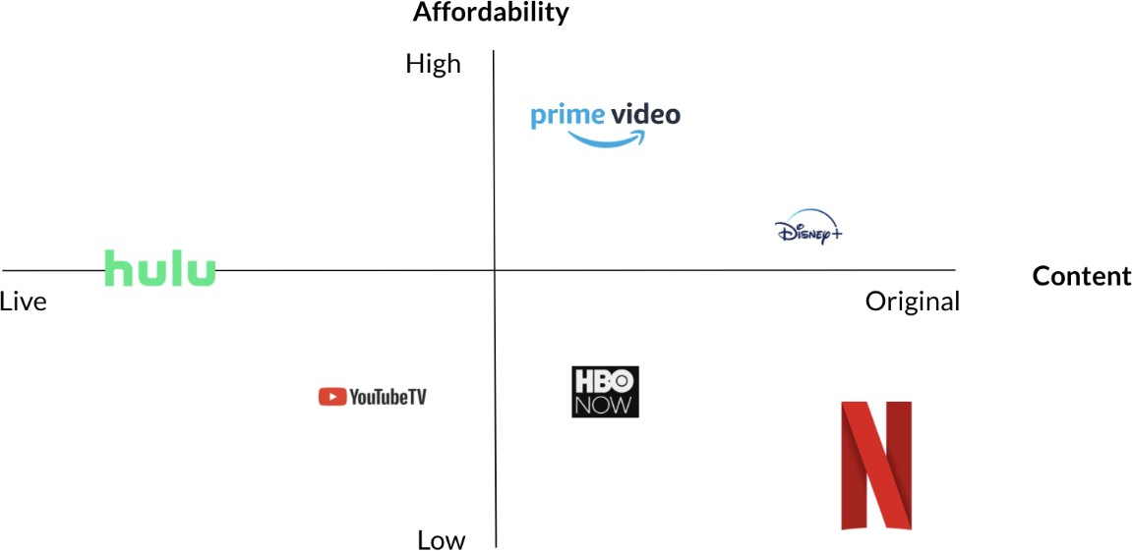

**Resources and Capabilities**

Netflix possesses **tangible resources** such as physical assets like buildings, equipment, and real estate, which support its operations and production units. Additionally, **intangible resources** like intellectual property, content distribution rights, technology, goodwill, and core competencies

contribute to Netflix's success. The company's **capabilities** include adaptability, meeting diverse customer needs, and a strong reputation and brand image among its members. These resources

and capabilities give Netflix a competitive advantage in the streaming market. A detailed breakdown of Netflix’s resources and capabilities is discussed in **Exhibit 9.**

## Resources and Capabilities Development

The **VRIN analysis** assesses the **competitive advantage** derived from a company's resources

and capabilities. Analyzing Netflix's VRIN analysis findings highlights areas where the company can enhance its competitive advantage and plan for long-term sustainability.

|  |  |  |  |  |  |  |
| --- | --- | --- | --- | --- | --- | --- |
| **Resources/ Capabilities** | **Valuable** | **Rare** | **Inimitable** | **Non-substitutable** | **Competitive Implication** | **Performance Implication** |
| **Brand Name** | Yes | No | No | Yes | Competitive Parity | Normal |
| **Proprietary Technology and Algorithms** | Yes | Yes | Yes | No | Non-sustainable Advantage | Above Normal |
| **Distribution Channels** | Yes | Yes | Yes | No | Non-sustainable Advantage | Above Normal |
| **Data Analytics and User Insights** | Yes | Yes | Yes | Yes | Sustainable Advantage | Above Normal |
| **Content Library** | Yes | Yes | Yes | Yes | Sustainable Advantage | Above Normal |

To maintain a competitive advantage and ensure long-term success, Netflix must **transform non-sustainable resources** and **capabilities** into **sustainable** ones. Companies can achieve this by cultivating market relationships, forming alliances, pursuing acquisitions, and fostering internal development.

In the **Market**, Netflix generates revenue through strategic partnerships with content producers and licensing agreements. Continually nurturing these relationships ensures sustainable growth and expansion. Key areas of focus should include reducing customer churn and improving loyalty through strategies like geographic expansion and ventures into production, gaming, and amusement parks.

Enhancing production and processes can be achieved through **Alliances** with production and technology companies. Collaborating with local firms fuels market growth and partnerships with

content rights holders and technology giants can strengthen capabilities, such as cloud

computing. Netflix has the opportunity to explore potential partnerships with major content rights holders like *Warner Bros.* or *Universal Studios*. Additionally, to improve its cloud

computing capabilities, Netflix can consider partnering with industry-leading technology giants like *Google* or *Microsoft*.

**Acquisitions** offer opportunities for growth, and Netflix can explore acquiring companies with valuable intellectual properties or extensive content collections to enhance its library.

Strengthening technological capabilities and diversifying offerings can be achieved through

acquisitions of companies in sectors like gaming. Netflix has the potential to consider acquiring renowned content creators like *A24* or *Blumhouse Productions* as potential targets. Additionally, to enhance their technological capabilities and expand their offerings, they can explore

acquisitions of companies like *Ubisoft* or *EA*.

**Internally**, Netflix can optimize data analytics and algorithms to provide tailored

recommendations and utilize predictive analytics for cost evaluation and decision-making. Investing in AI and machine learning enhances pricing understanding and industry trends.

Expanding internal content development through '*Netflix Studios*' is another avenue for growth.

## The Non-market Environment

The term "Non-market Environment" refers to external forces and factors that impact a business's operations and performance but are unrelated to its market activities. Analyzing

Netflix's non-market environment involves utilizing **PESTEL Analysis (Exhibit 10)** for macro factors and the 4I's Framework to assess their management of non-market issues. In the

entertainment services industry, significant influences include content regulations, censorship, data privacy, intellectual property, international laws, political instability, and carbon footprint.

The implementation of the *Audiovisual Media Services Directive (AVMSD)* in 2018 had a direct impact on Netflix's content library and subscriber retention. Using the **4I's Framework (Exhibit 11)**, Netflix addressed this issue with passive and anticipatory approaches, responding to the policy in the European Union and anticipating localized content needs in other countries. Global expansion strategies are influenced by the non-market environment, including international politics and the economy. Netflix also addresses environmental concerns to enhance consumer

confidence by committing to reduce emissions from its operations and electricity use by 45% by 2030. Overall, strategic responses to the non-market environment are crucial for business performance.

## Strategic Tradeoffs

A company's tradeoffs involve making decisions that involve sacrificing one aspect in favor of another. Netflix has strategically chosen to **prioritize content creation over licensing**, heavily

investing in original content. This approach allows Netflix to offer exclusive and unique content, distinguishing itself from competitors. By producing its own content, Netflix gains more control over creative direction, customization to audience preferences, and the ability to build a loyal subscriber base. While licensing offers more options, prioritizing creation gives Netflix a

competitive edge in the streaming market.

Netflix positions itself as a **value leader by charging higher prices**, aiming to convey its

commitment to quality and enhance subscriber value. This tradeoff allows Netflix to allocate resources to content acquisition, production, and technological advancements, resulting in a

diverse range of high-quality, exclusive content, and ongoing platform improvements. By

differentiating as a value leader, Netflix strives to maintain a strong market position by providing perceived value that justifies the higher price tag, leading to customer satisfaction and long-term profitability.

Netflix is also exploring a **shift from a subscription-based to an ad-based revenue model** to diversify income and attract a broader audience. While this presents growth opportunities,

ensuring a positive user experience remains crucial. This move represents a strategic decision to adapt to market changes and optimize financial performance.

## Key Takeaways

Netflix's SWOT analysis emphasizes its strengths in brand, original content, pricing, technology, and growth. A User-friendly interface, global presence, and a strong platform contribute to success. Challenges include new competitors, regulations, and capacity limitations. To retain and attract customers, Netflix must produce compelling content and address market risks.

Maintaining vigilance and adaptability is crucial to leverage strengths and opportunities while mitigating threats.

In conclusion, the comprehensive analysis confirms Netflix's dominance in the streaming media industry. The company's content strategy, global reach, technological advancements, and

customer-centric approach have been instrumental in its remarkable success. Skillfully managing external factors, executing business strategies, and making strategic tradeoffs have contributed to Netflix's growth and financial performance. To sustain its position in a rapidly evolving industry, Netflix must prioritize innovation, adaptability, and strategic decision-making.

# Exhibits

**Exhibit 1: Audiovisual Supply Chain/Key Actors**

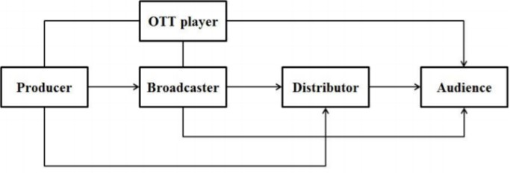

## Exhibit 2: Threat of New Entrant Assessment

|  |  |
| --- | --- |
| **Barrier to Entry** | **Assessment** |
| **Supply-side economies** of scale or learning | Netflix benefits from economies of scale, which means as its subscriber base grows, it benefits from lower unit costs, due to its large fixed cost base. The more paying subscribers Netflix can attract, the more profitable the company can be |
| **Demand-side benefits** of scale (e.g. network effects) | The Netflix platform has very strong indirect network effects. The more movies and TV shows on the platform, the more subscribers value the service. Users need to feel like they are getting access to high-quality, new, and exclusive content in order to see value in the product. |
| Customer **switching costs** or loyalty | As the sub-industry is dominated by established companies with a significant presence in filmmaking, a company attempting to enter would face challenges of consumer preferences, busy subscribers not having time and financial constraints. From this perspective switching costs are high**.** |
| High **capital requirements** | Yes, the high financial outlay required for content production prevents poorly funded new entries from entering the industry. Financing for technology development, licensing, and original content creation directly raises the cost. |
| Other **first-mover advantages** | Yes, brand awareness and loyalty, well-developed global distribution channels, established bottling network, and a foothold on limited shelf space. |
| Threat of **incumbent aggression** | Not very relevant. They are a vertically integrated company that has produced its original content since 2013. |
| **Government restrictions** | Very relevant. Restrictions on media ownership by foreigners, on the amount of media anyone can control and on how information flows within a country present a major entry barrier |

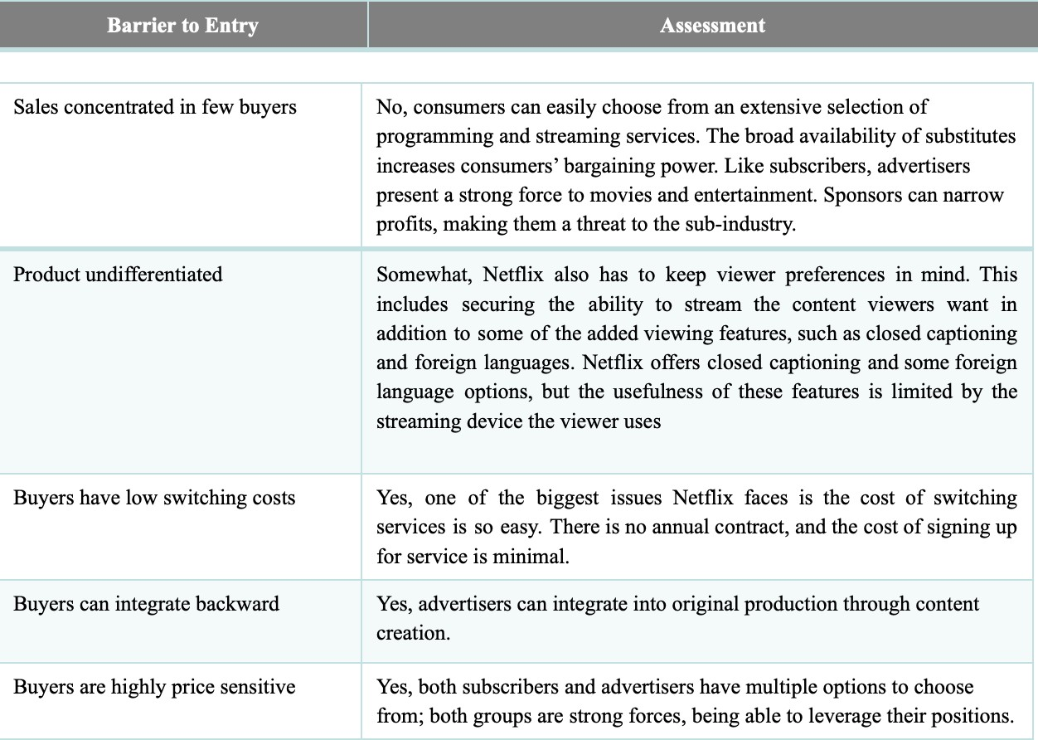 **Exhibit 3: Bargaining Power of Buyer Assessment**

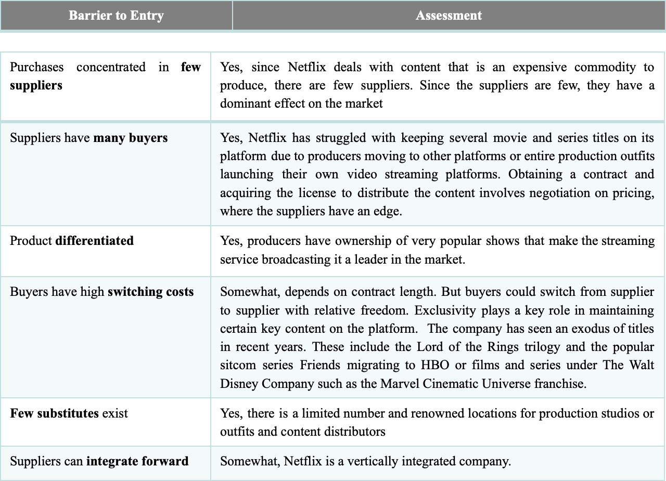 **Exhibit 4: Bargaining Power of Supplier Assessment**

**Exhibit 5: Threat of Substitutes Assessment**

**Assessment**

**Barrier to Entry**

|  |  |
| --- | --- |
| Attractive  **price-for-performance trade-off** | Suppliers: Yes, many platforms are available if a lower price is achieved.  Consumers: Yes, the curation of the content plays a big role in the perceived value of the platform. |
| Customer **switching costs** low | Are low for suppliers and consumers. |

**Exhibit 6: Competitive Rivalry Assessment**

**Assessment**

**Barrier to Entry**

|  |  |
| --- | --- |
| **Product undifferentiated** | In movies and entertainment, demand has leveled off. This means companies are simultaneously engaged in the same practices, resulting in intense rivalry and lower profits. However, each content producer does have differentiated shows. |
| Buyers have low **switching costs** | No. Locked by contracts |
| **High fixed-to-variable cost** ratio | The industry requires large financial backing. Technology development, licensing, and original content creation are fixed costs. |
| Excess industry **capacity** | Yes. Demand declines when the market approaches saturation, which constitutes a threat. More companies are creating or merging content to rival one another. |
| Product **perishable** | No |
| **Many** similarly-powerful  **competitors** | Yes, Within the sub-industry of movies and entertainment, the number of competitors have started to decrease, resulting from the consolidation process of mergers and acquisitions. The sub-industry is moving towards becoming a few powerful companies. |
| **Low industry growth** rates | No, but decreasing due to industry saturation. |
| High **exit barriers** | Yes |

**Exhibit 7: Intensive Growth Strategy of Netflix**

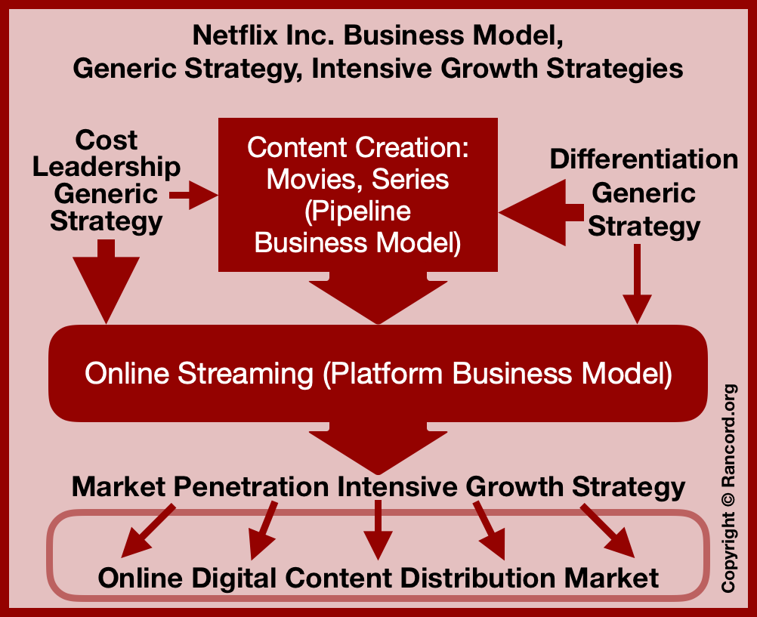

**Exhibit 8: Detailed Competitor Analysis**

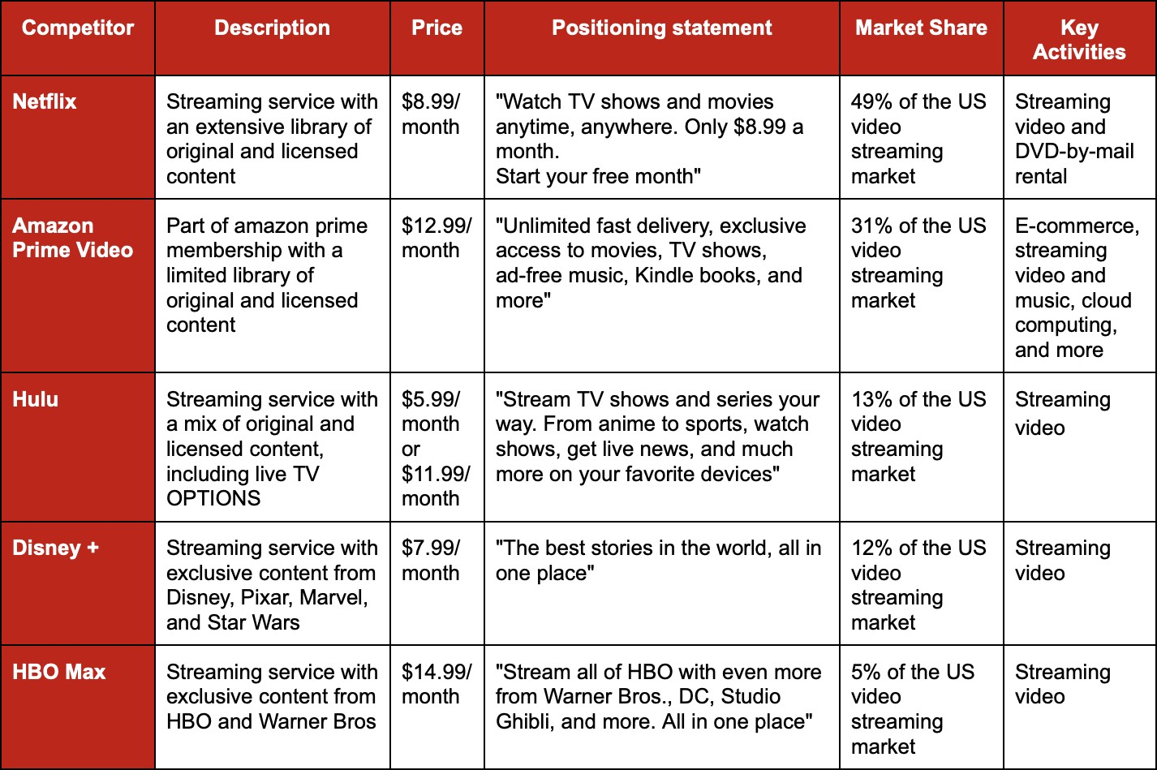

**Exhibit 9: Resources, Capabilities, and Competencies of Netflix**

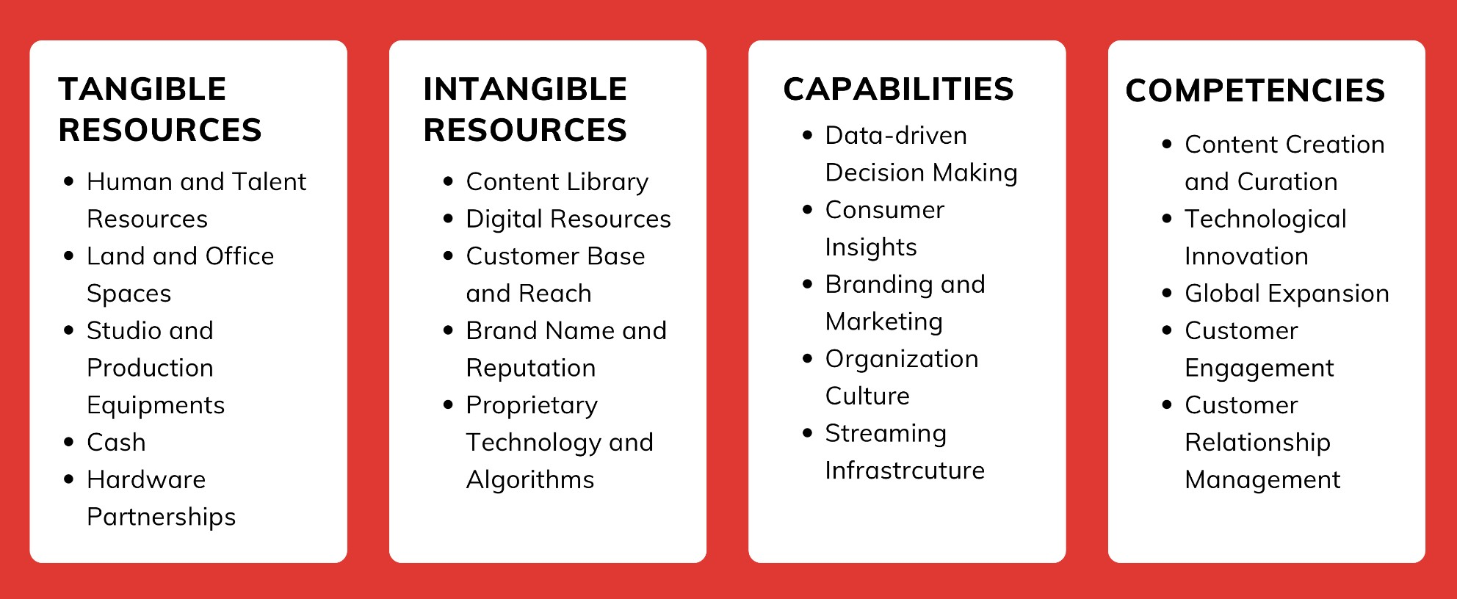

**Exhibit 10: PESTEL Analysis of Netflix**

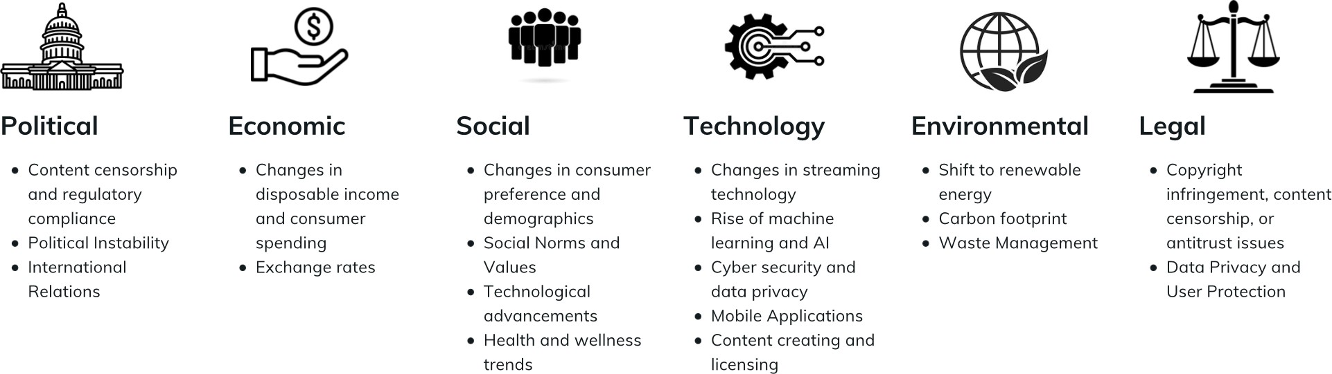

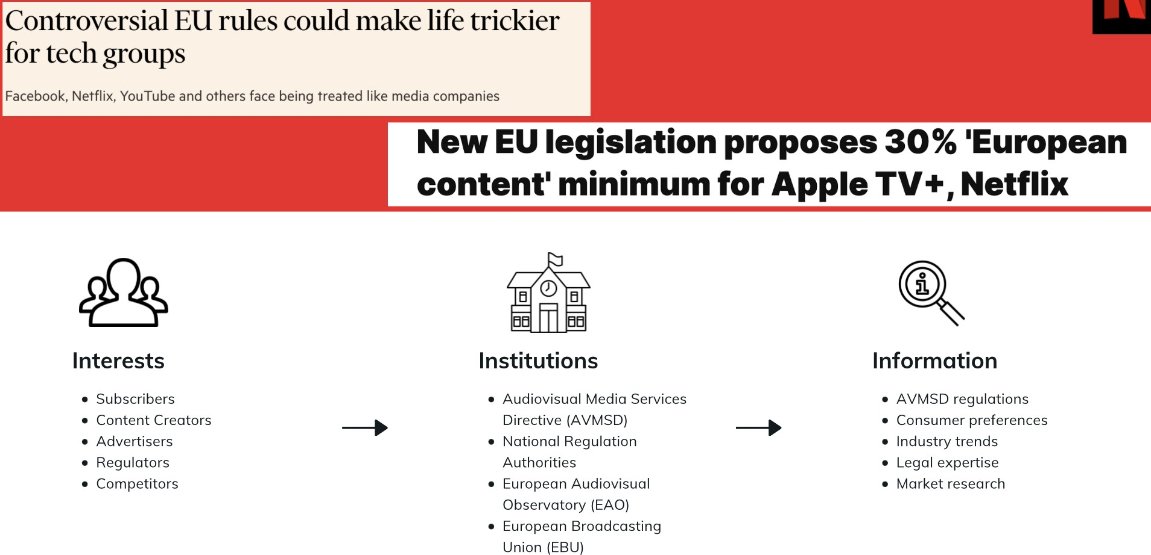 **Exhibit 11: 4 I’s Framework for AVMSD Issue**

**Sources and References**

* 1. [https://medium.com/@vik975/netflix-inc-competitive-position-and-analysis-7ea89a4bb35 6](https://medium.com/%40vik975/netflix-inc-competitive-position-and-analysis-7ea89a4bb356)
  2. <https://egrove.olemiss.edu/cgi/viewcontent.cgi?article=2780&context=hon_thesis>
  3. <https://ir.netflix.net/ir-overview/profile/default.aspx>v
  4. <https://bstrategyhub.com/swot-analysis-of-netflix-2019-netflix-swot-analysis/>
  5. [https://about.netflix.com/en#](https://about.netflix.com/en)
  6. <https://www.edrawmax.com/article/netflix-porters-five-forces-analysis.html>
  7. <https://www.mbaskool.com/five-forces-analysis/companies/18373-netflix.html>
  8. [https://entertainmentstrategyguy.com/2020/10/30/netflix-is-raising-prices-because-it-is-sh ifting-strategies-most-important-story-of-the-week-30-oct-20/](https://entertainmentstrategyguy.com/2020/10/30/netflix-is-raising-prices-because-it-is-shifting-strategies-most-important-story-of-the-week-30-oct-20/)
  9. <https://businesschronicler.com/competitors/netflix-competitors-analysis/>
  10. <https://abhijeetpratap.medium.com/vrio-analysis-of-netflix-2a67751f9408>
  11. [https://www.rancord.org/netflix-vrio-vrin-analysis-value-chain-analysis-resource-based-vi ew](https://www.rancord.org/netflix-vrio-vrin-analysis-value-chain-analysis-resource-based-view)
  12. <https://www.edrawmax.com/artcile/netflix-pestel-analysis.html>